Evidence for Implementation and Testing Unit.

Pauline Cairns

E21

I.T 1- Demonstrate one example of encapsulation that you have written in a program.

Fruit Machine project

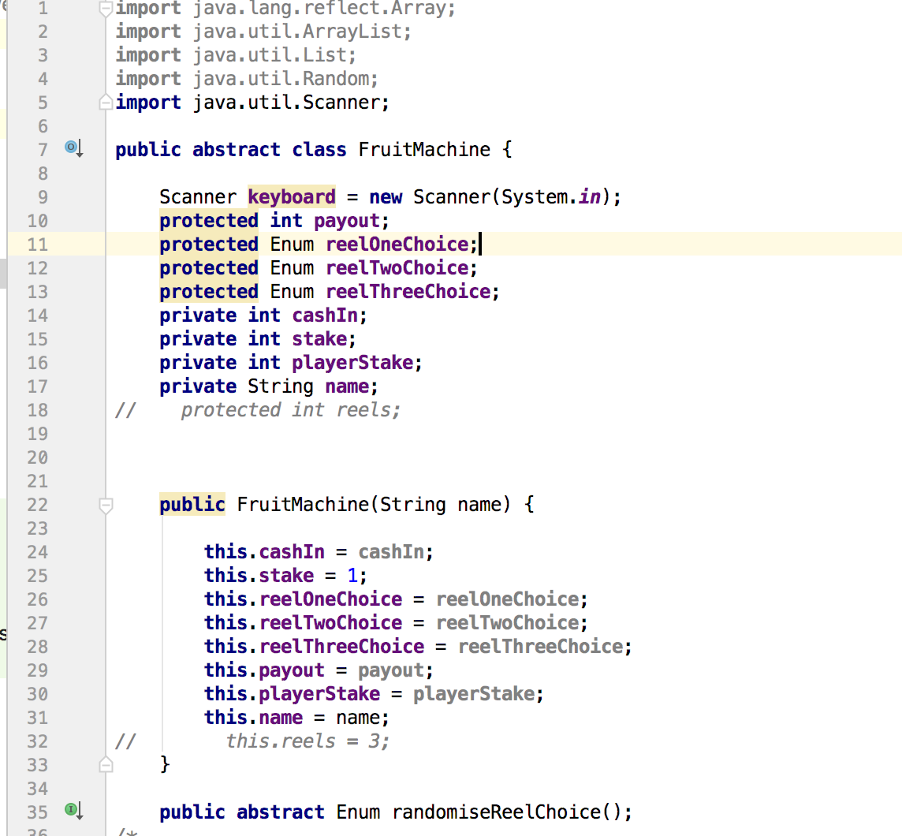

I.T 2 - Example the use of inheritance in a program.

CodeClanTowers homework

Class

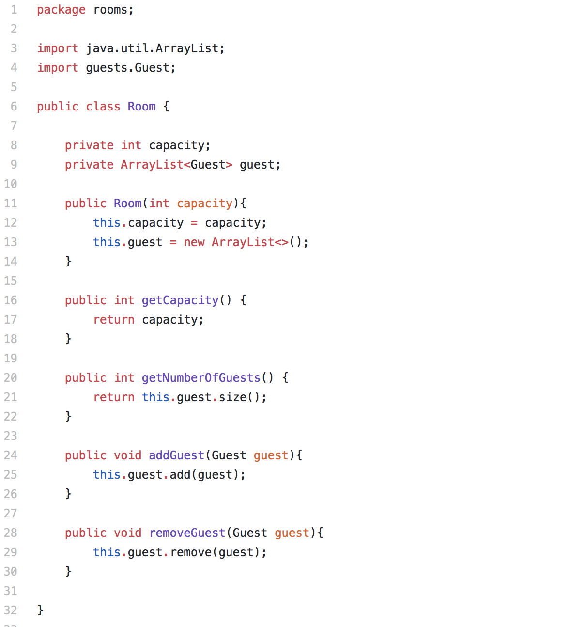

**A Class that inherits from the previous class**

**Bedroom extends Room and takes in information from BedroomType**

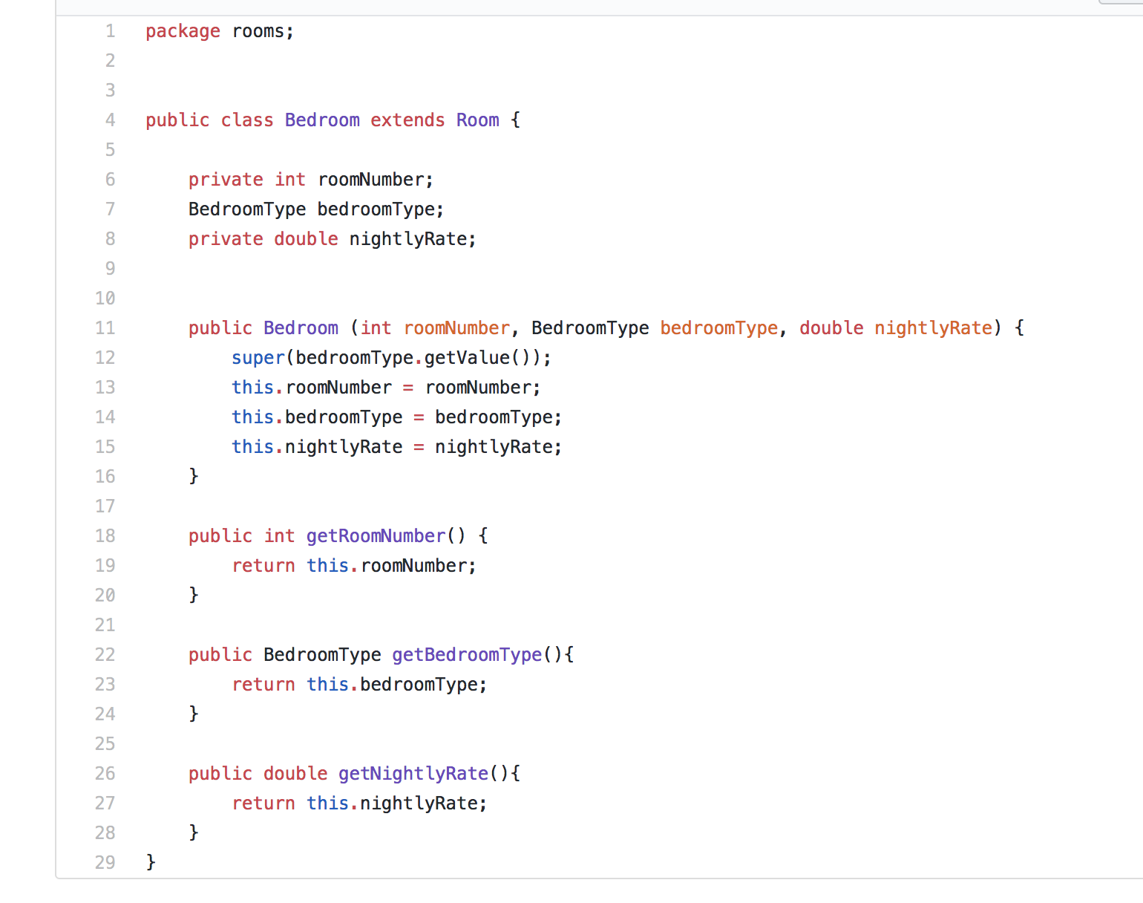

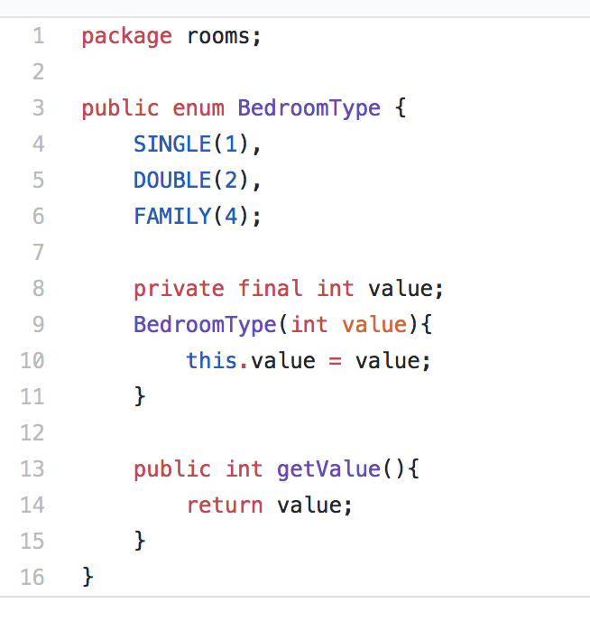

I.T 3 - Example of searching

From film.rb in Cinema weekend 3 homework

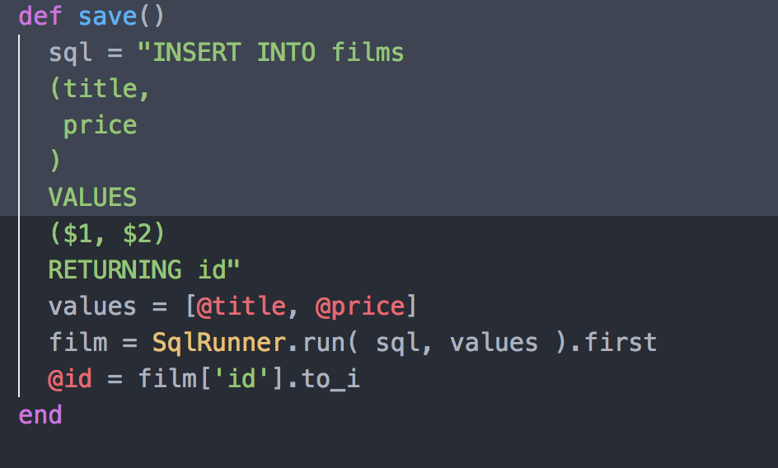

How many people watching one film? (in this case the Jason Bourne film)

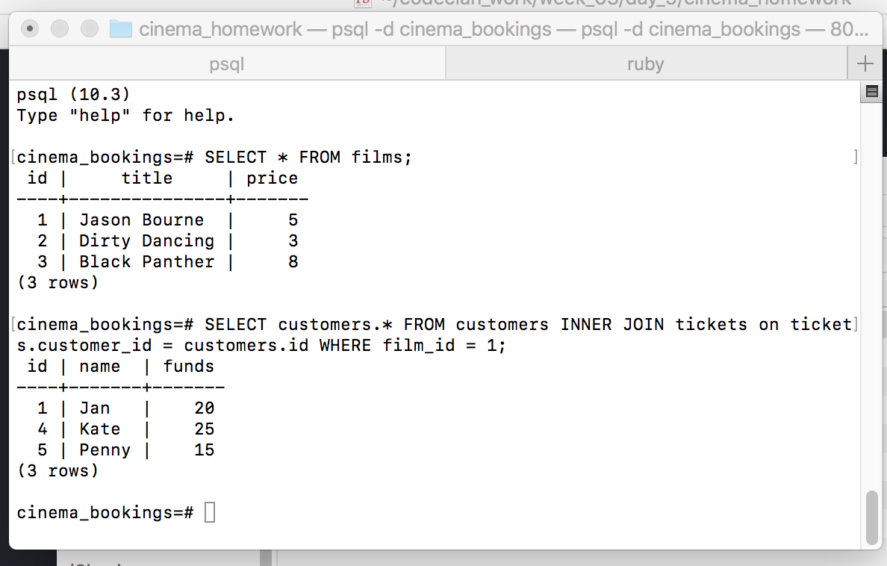

I.T 4 – Example of sorting

Week 1 Day 3 arrays_hashes_practice homework

Sorting an array to get Erik’s lowest lottery number

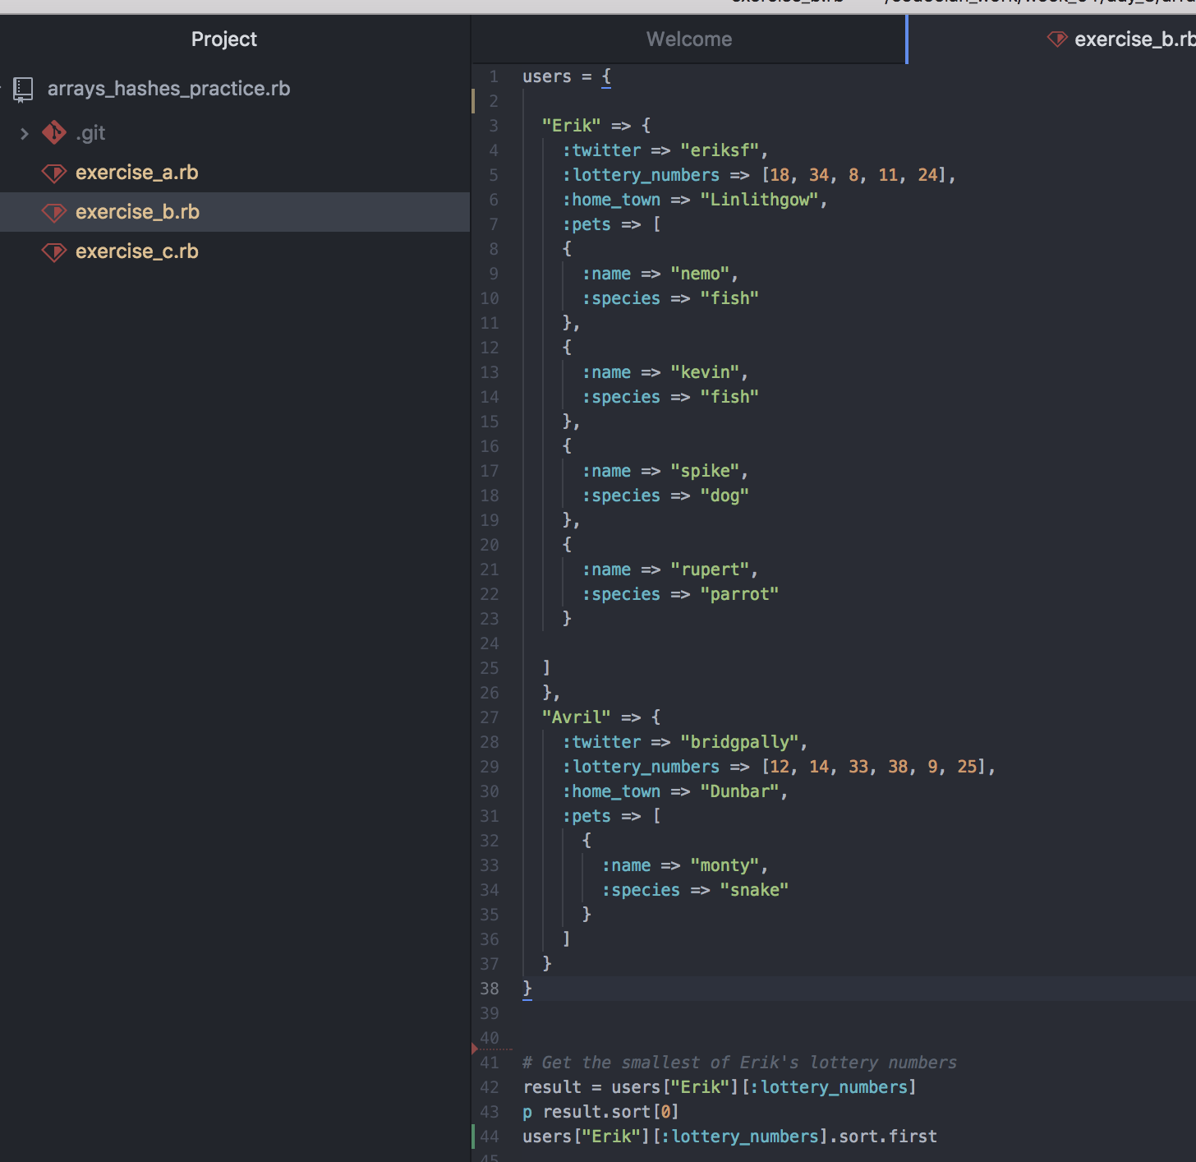

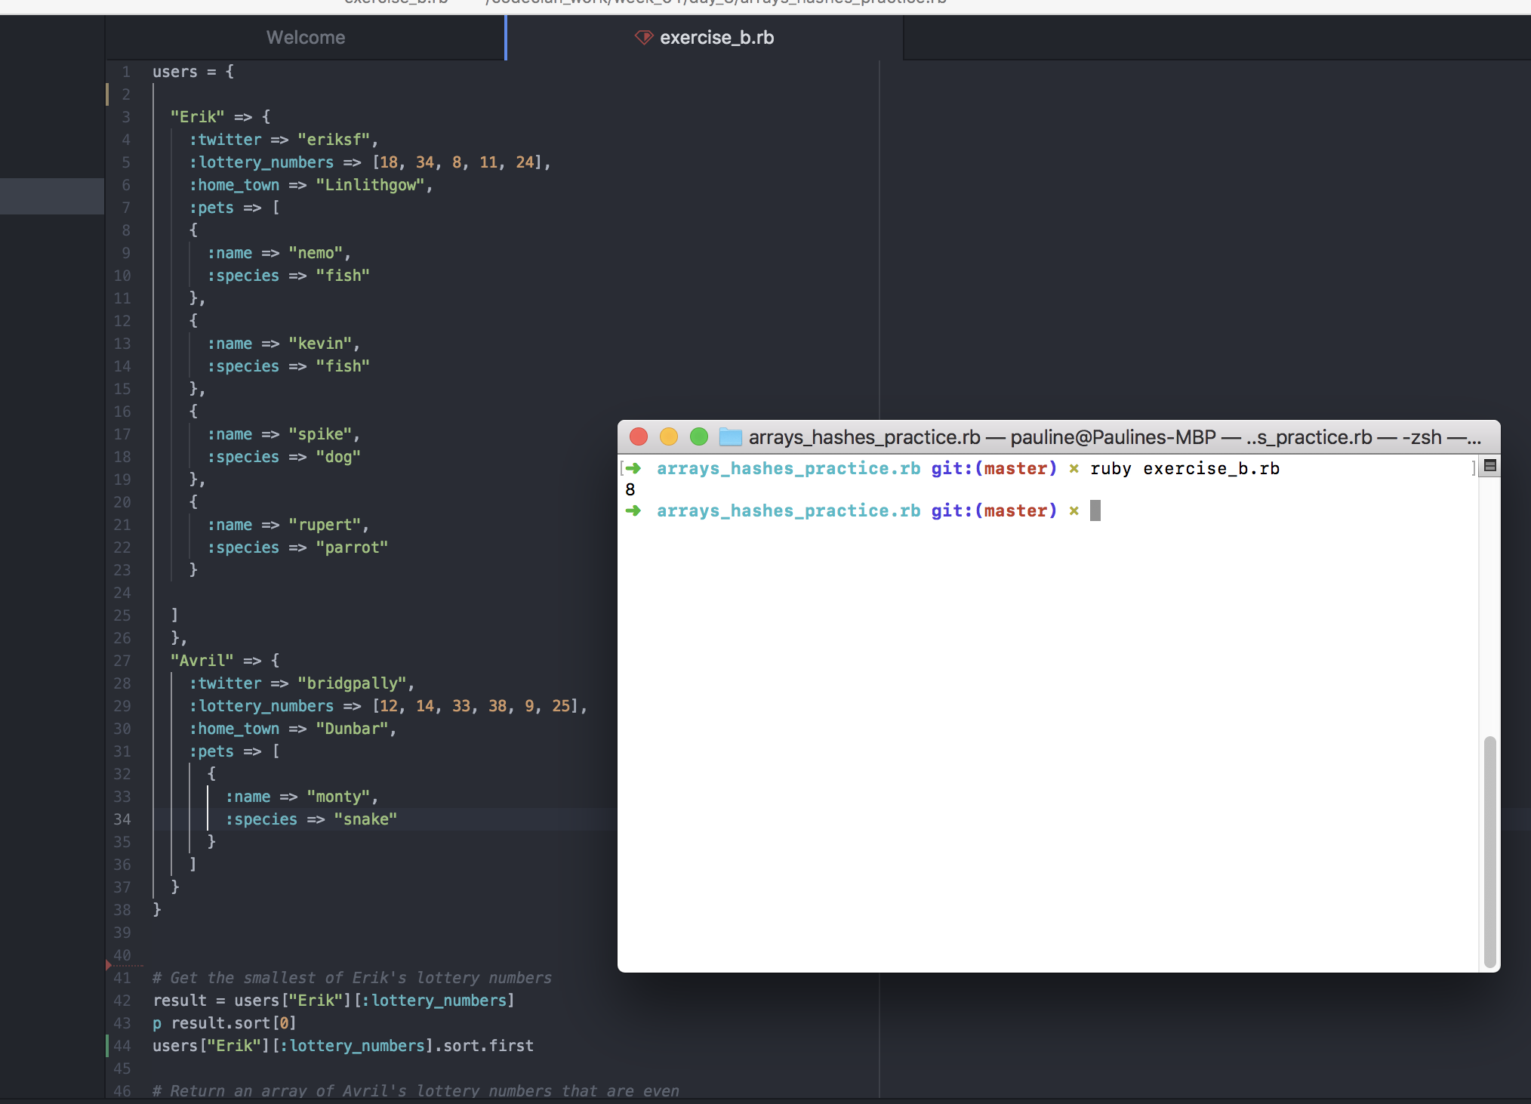

I.T 5 - Example of an array, a function that uses an array and the result

Guest array, check_guest_in function and result through proof that test passed (although as it is included within a set of test have shown all tests and them passing)

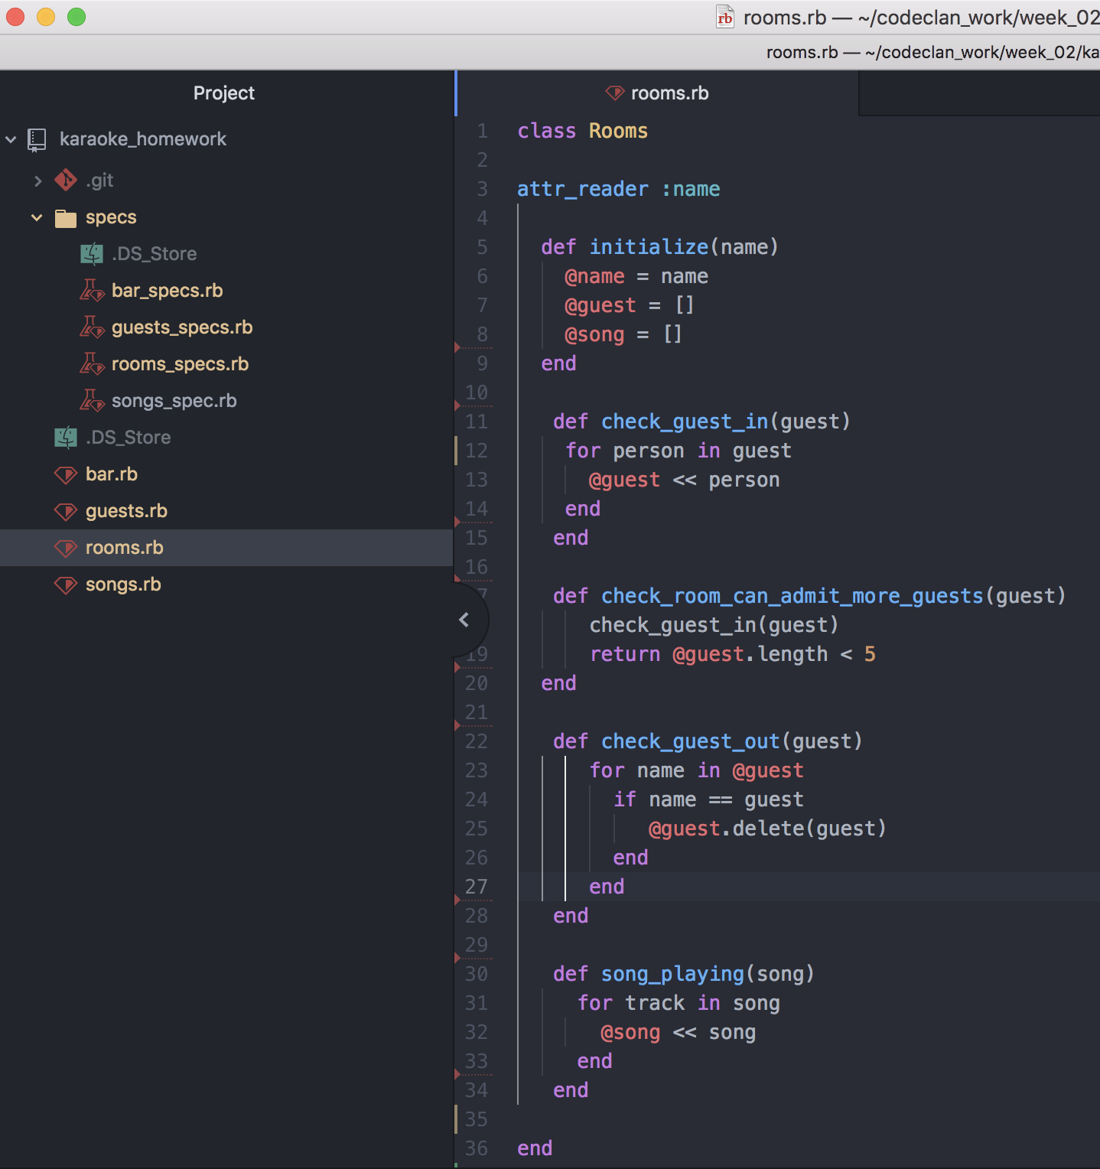

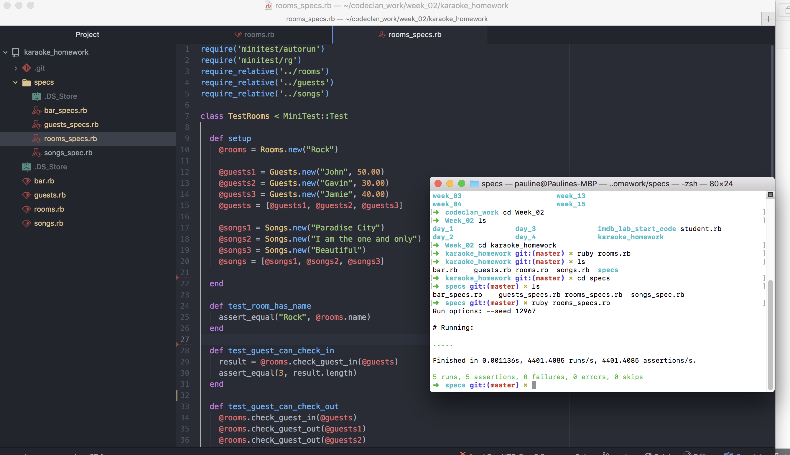

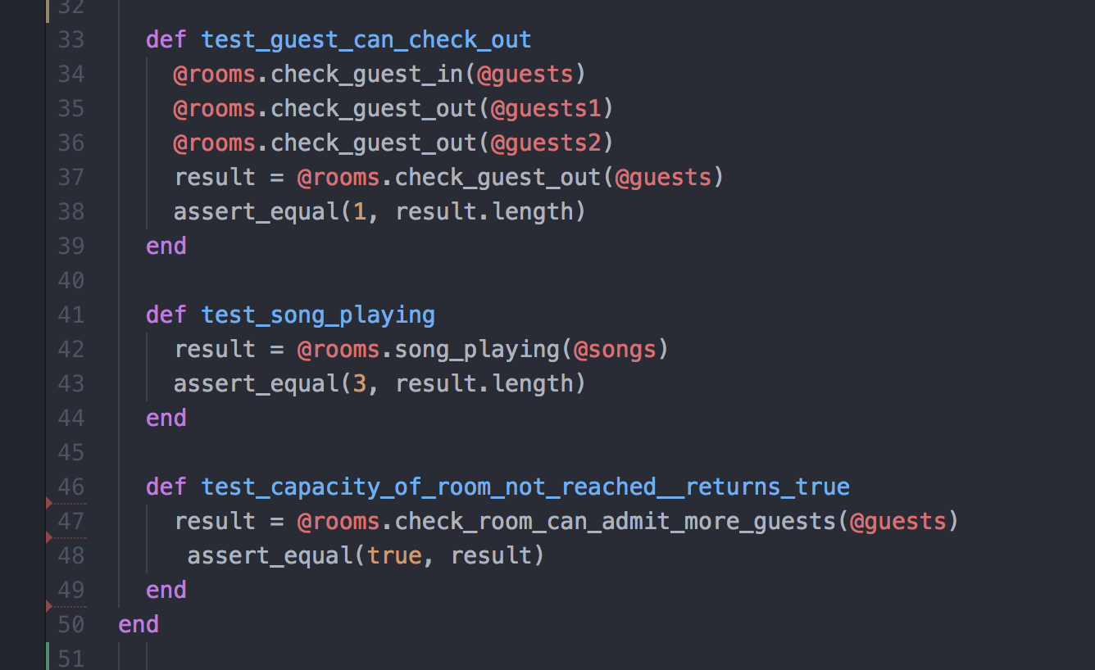

I.T 6 - Example of a hash, a function that uses a hash and the result

Week 6 Day2 - Library homework

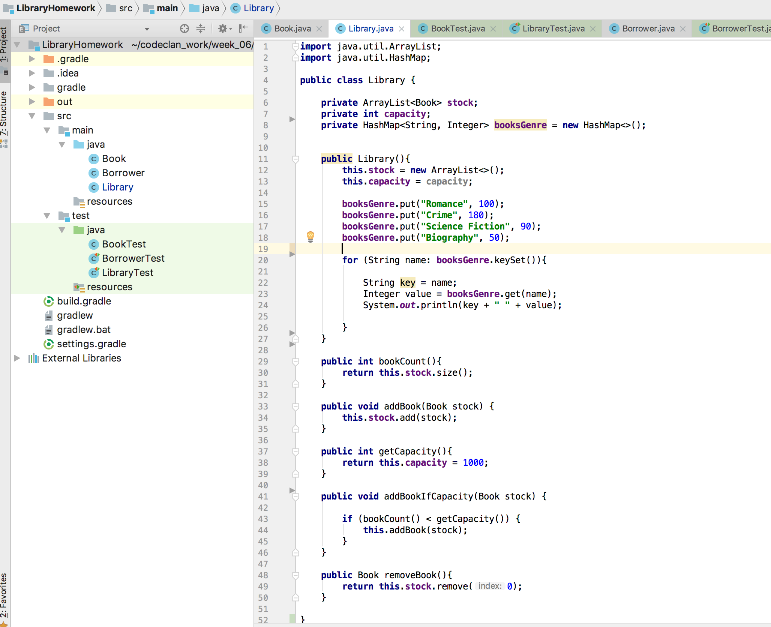

Demonstrating result of function working

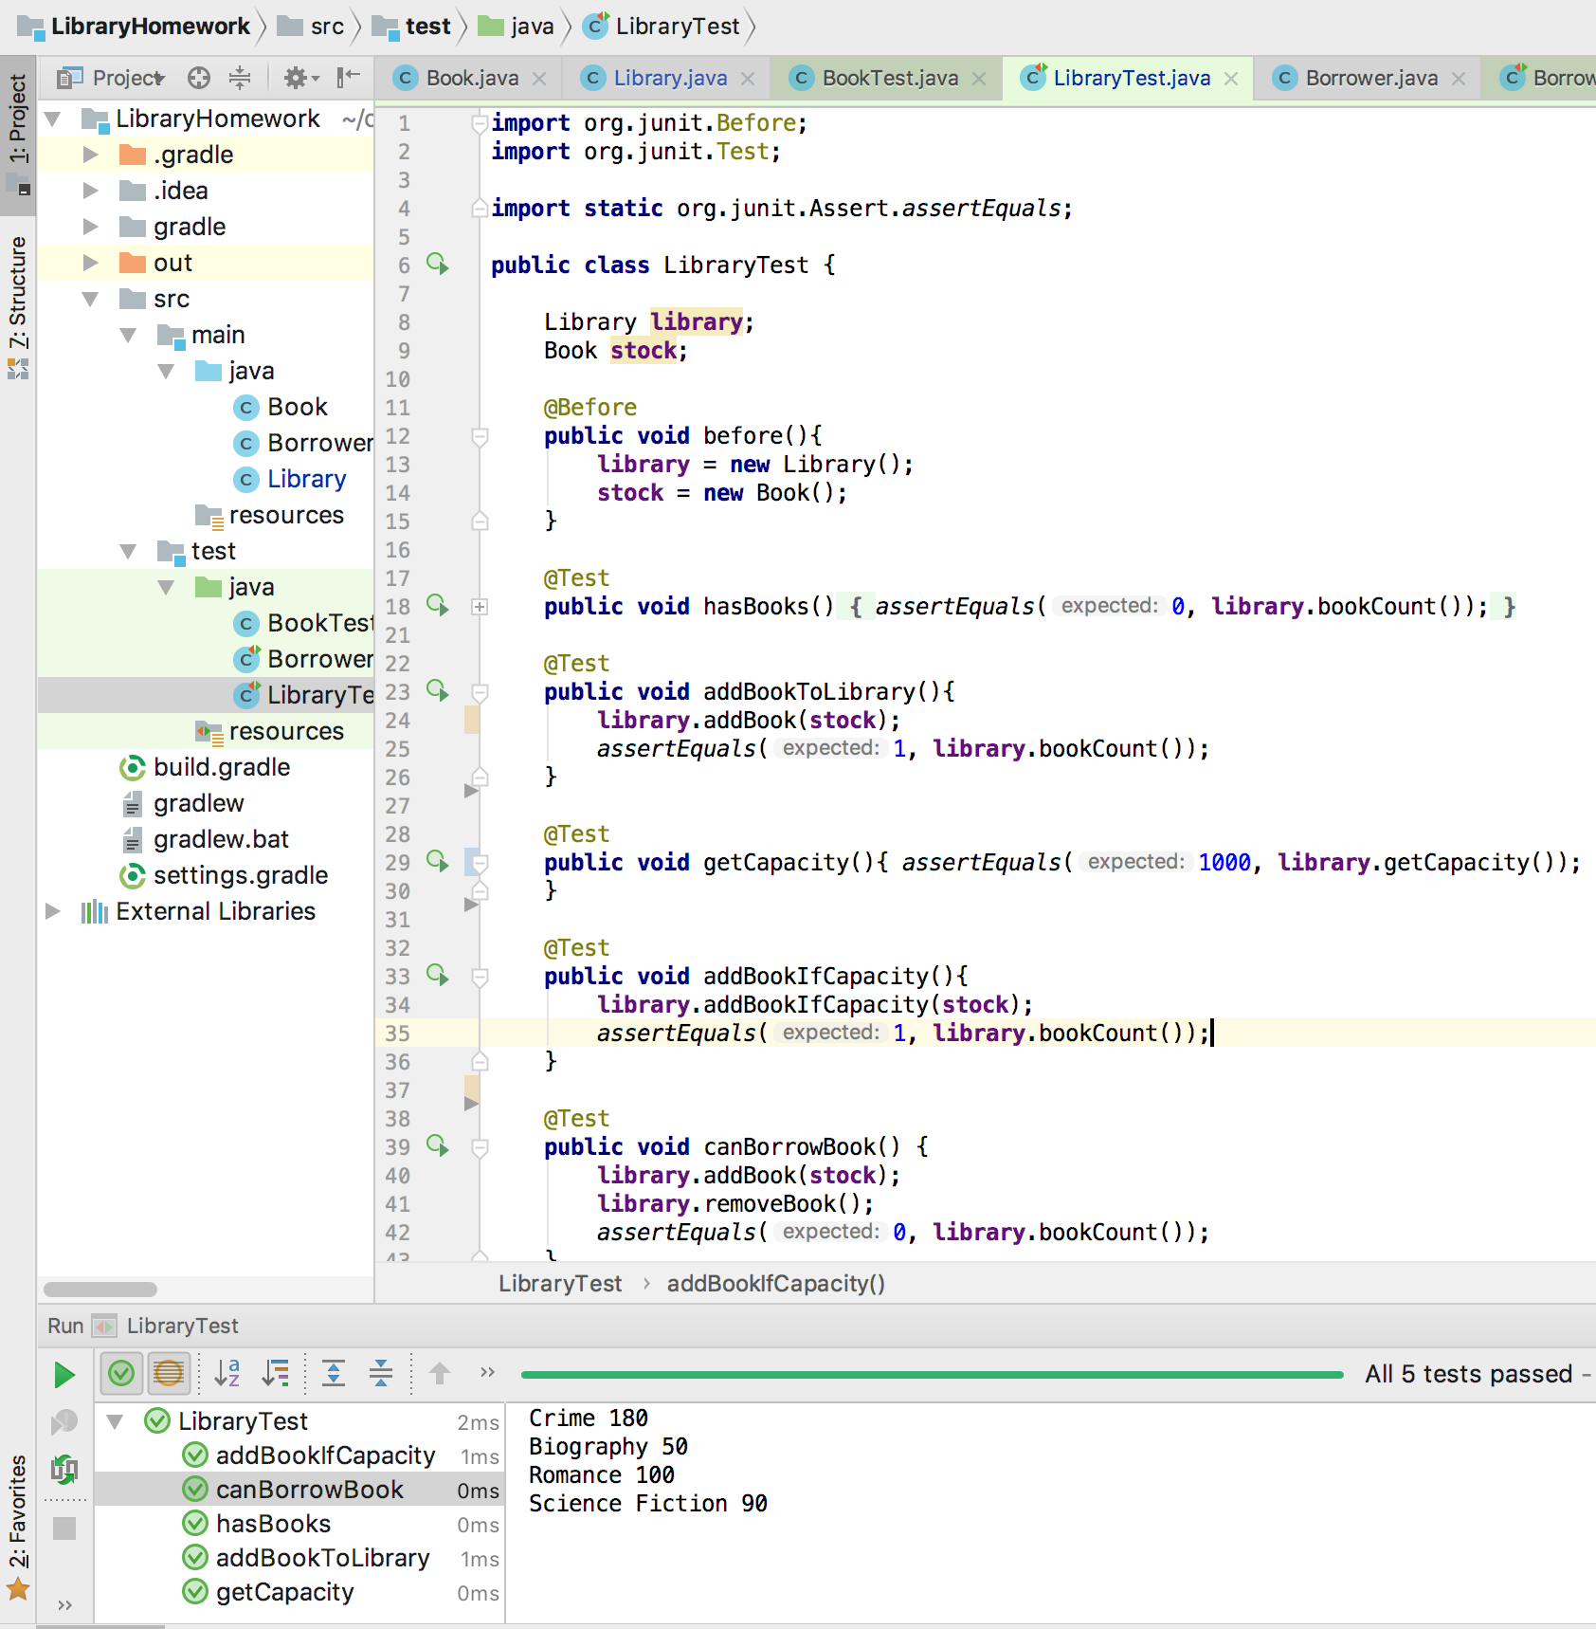

I.T 7 - Example of polymorphism in a program

StereoPolymorphism

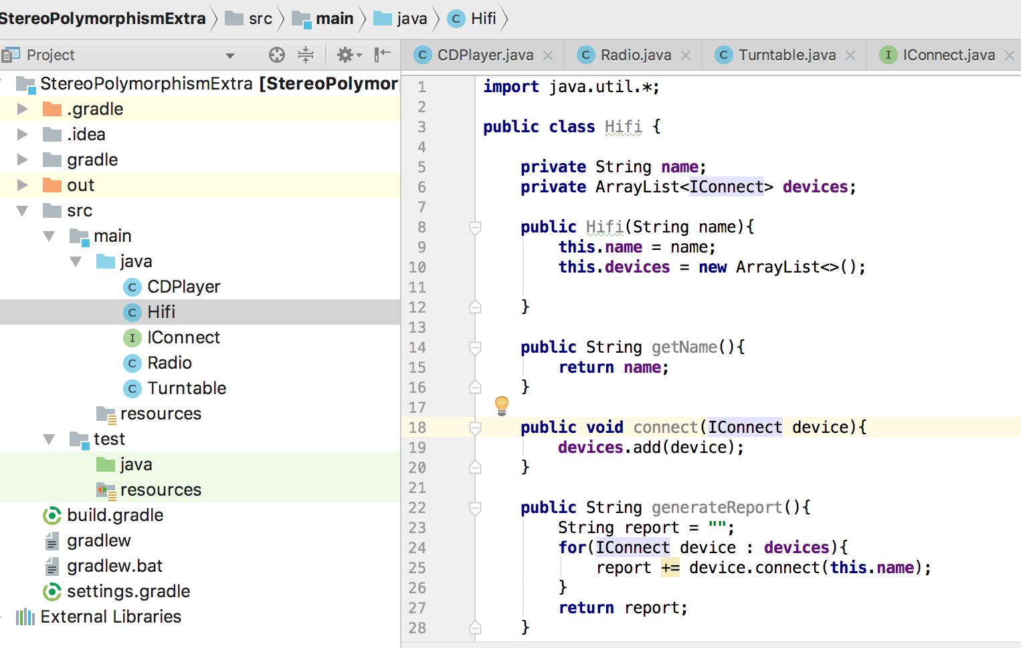

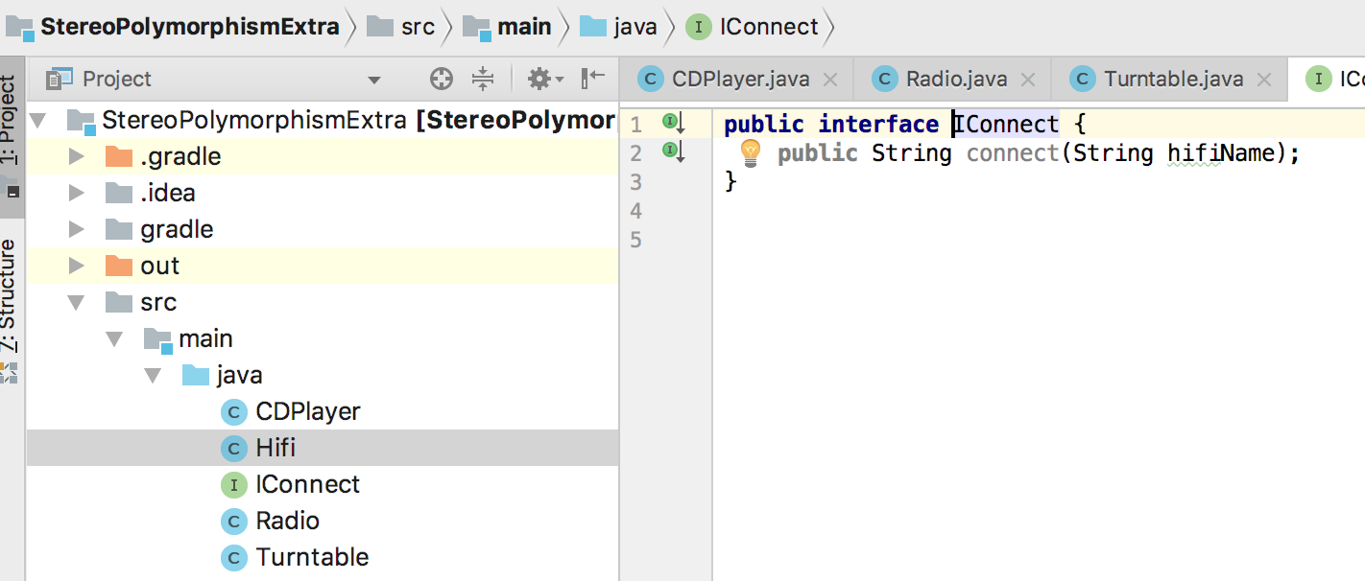

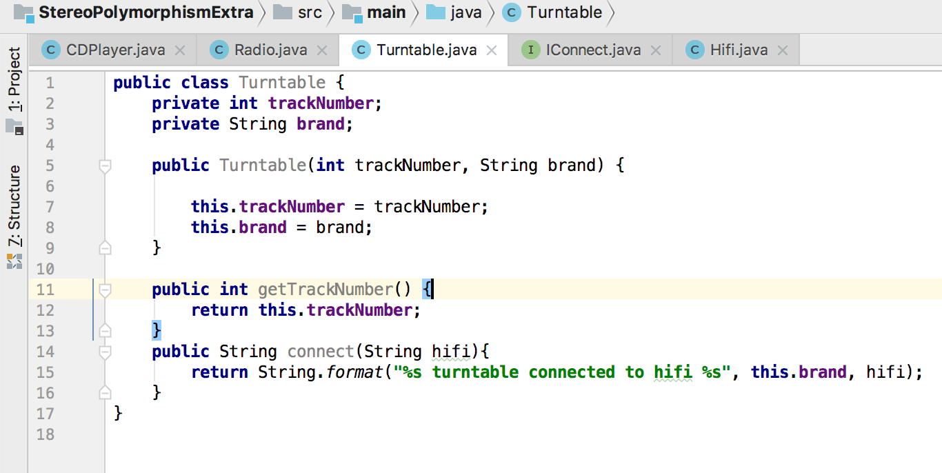

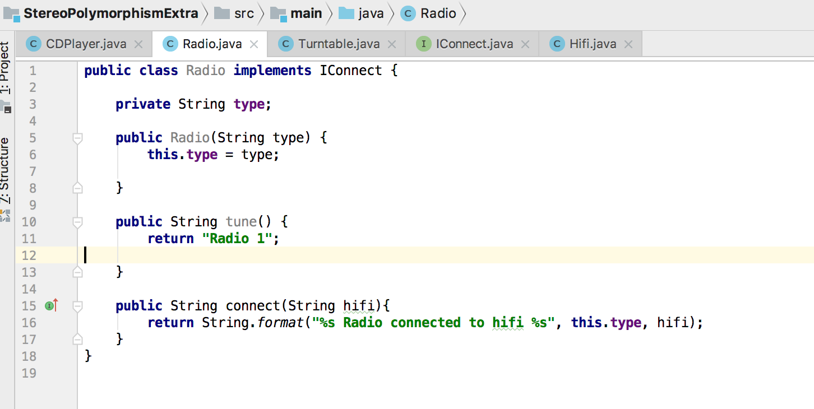

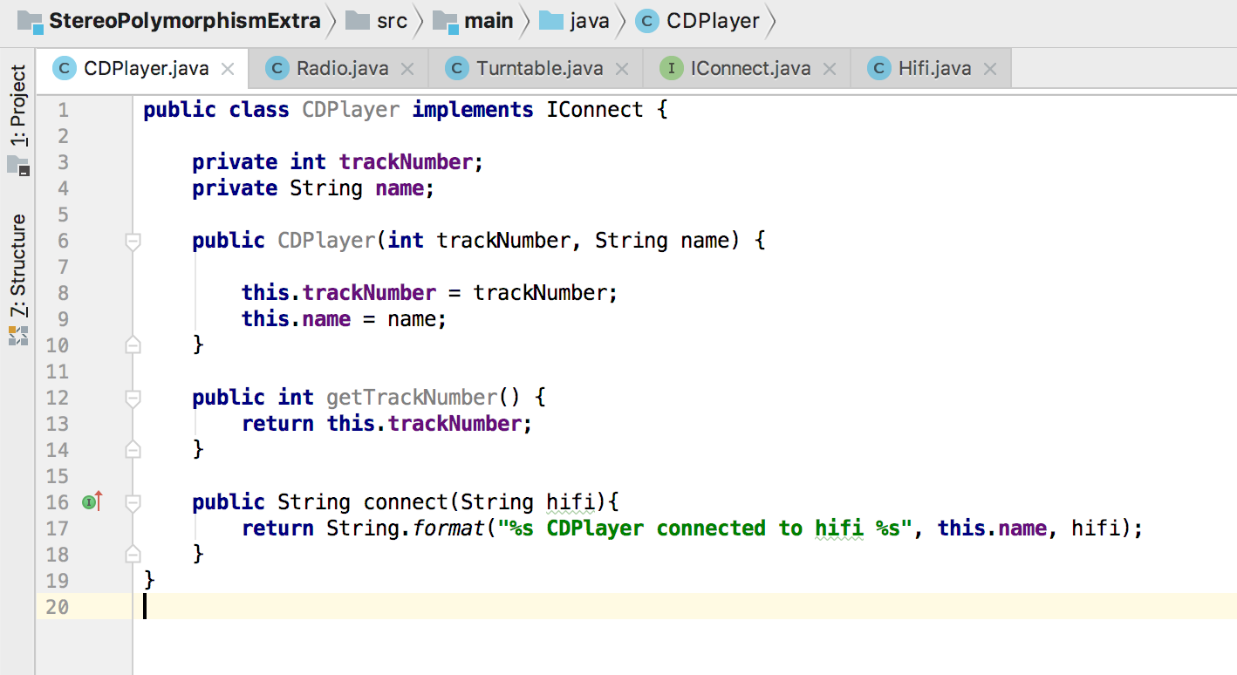

**Coding exercise 1: Static and Dynamic testing task A – see documentation at P18 in Project Unit file**

**Coding exercise 2: Unit and Integration testing task B**

**Unit Testing – two Atom screenshots provided as difficult to read otherwise.**

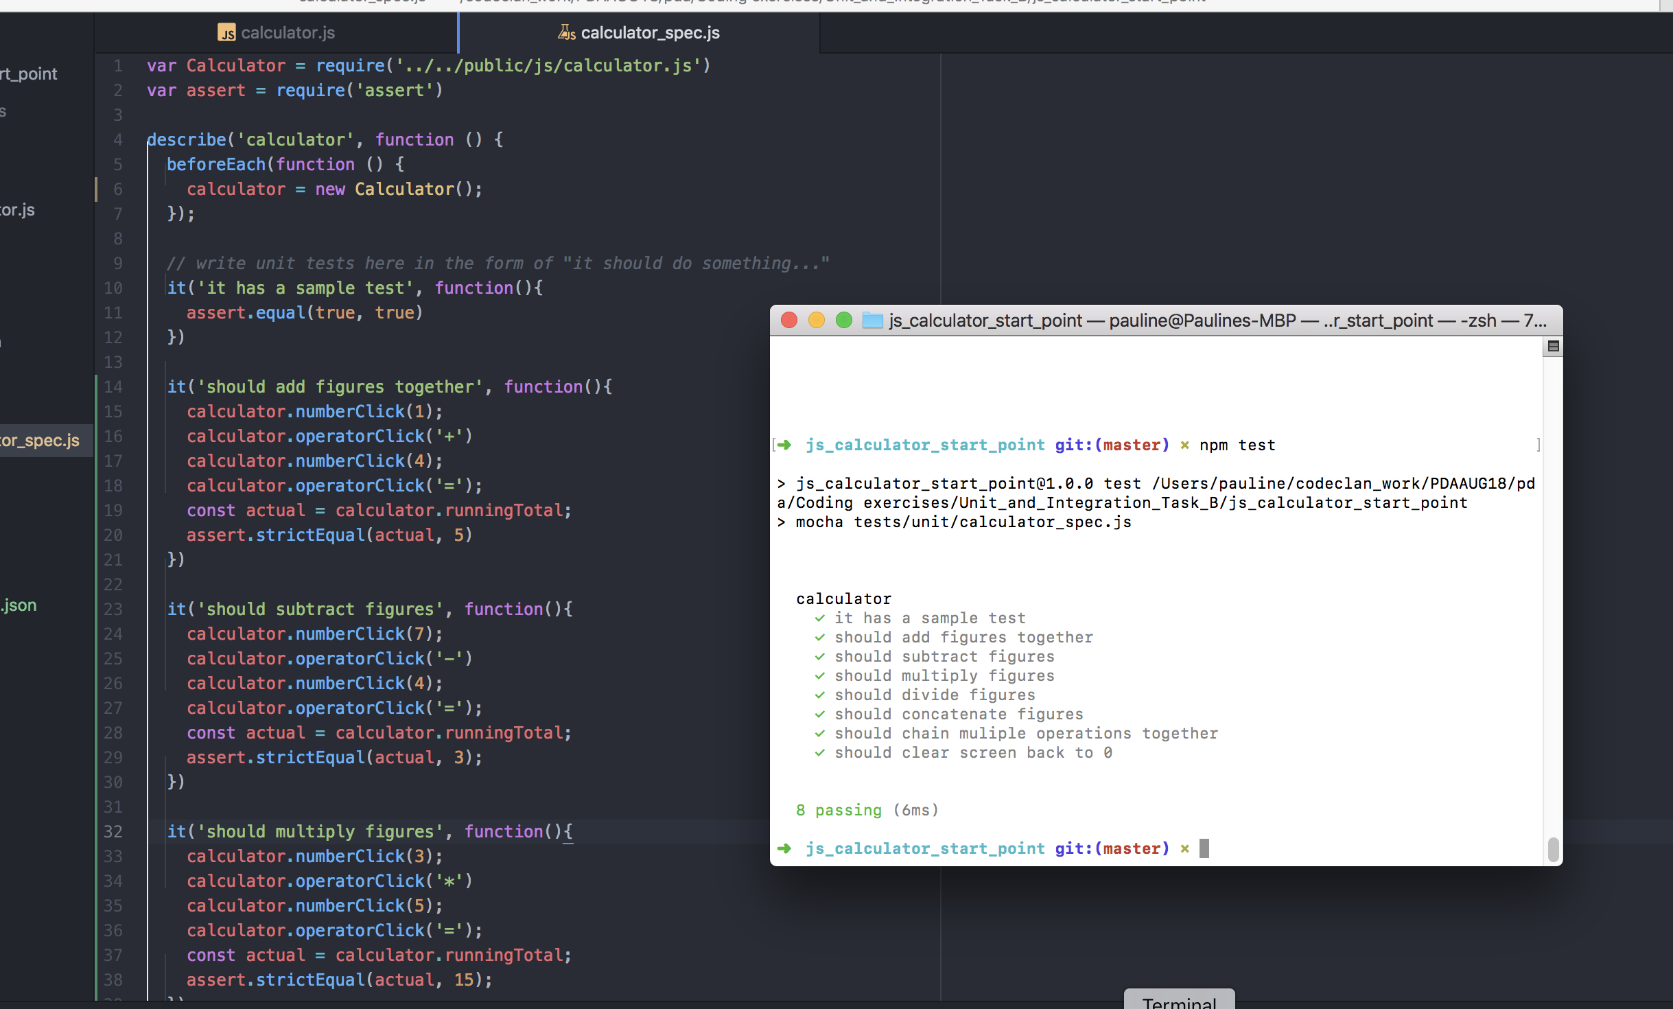

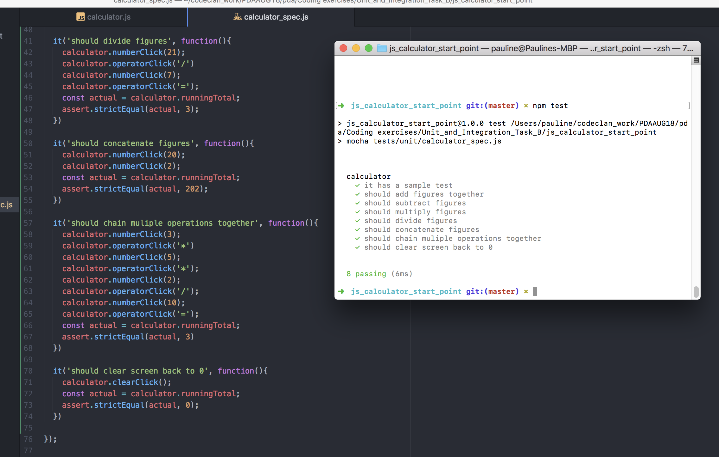

Integration/Acceptance tests

